ORR Orange roughy *Hoplostethus atlanticus*

The Orange Roughy is a demersal species that is found in continental slope waters at depths between 500 m and 1000 m.

It grows to about 50 cm in length in Australia although up to 60 cm elsewhere

Juveniles feed mainly on benthopelagic and mesopelagic crustaceans; adults feed mainly on mesopelagic fish and squid.

Dietary studies of *H*. *atlanticus* found that they consume about 1% of their body weight per day.

The majority of species fed predominantly on pelagic or benthopelagic prey.

Bathylagid fishes contributed most to the diet of *H*. *atlanticus.* Pelagic crustaceans such as carid and penaeid prawns also contributed to these species’ diets. With increasing size, the proportion by weight of crustaceans declined in the diet of *H*. *atlanticus*, while that of fish, particularly pelagic, increased.

Frequency of prey occurrence:

benthic crustaceans: 11.4

benthopelagic fish: 7.4

pelagic invertebrates: 8.5

pelagic fish 7.4

*H*. *atlanticus* ate fish, prawns and squid. The most-favoured fish prey, from the identifiable component, was a bathylagid species that could not be further identified. *Melanolagus*

*bericoides*, a bathylagid, was amongst the most abundant micronektonic fish in the water column in our study area. Bathylagids were also prominent in the diets of both juvenile and adult roughy caught off western Tasmania, in the Great Australian Bight (Bulman and Koslow 1992) and off New Zealand (Rosecchi *et al.* 1988).

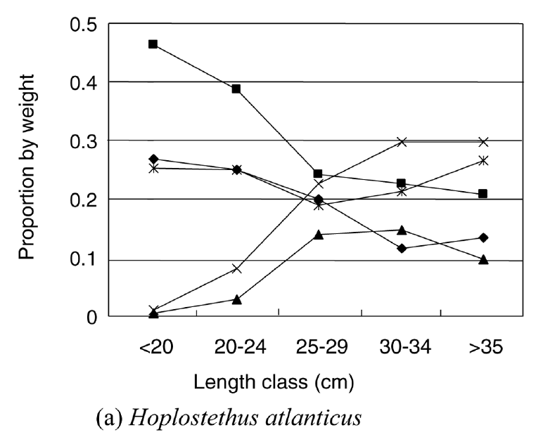

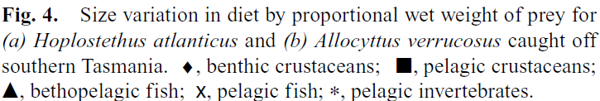

.

Orange Roughy <20 cm

|  |  |
| --- | --- |
| **prey item** | **probability of consuming** |
| ZME | 0.2 |
| ZKL | 0.3 |
| PRW | 0.2 |
| SAL | 0.1 |
| ORR | 0.01 |
| FDD | 0.01 |
| FMP | 0.01 |
| MAZ | 0.3 |

Orange Roughy 20-24 cm

|  |  |
| --- | --- |
| **prey item** | **probability of consuming** |
| ZME | 0.2 |
| ZKL | 0.2 |
| PRW | 0.2 |
| SAL | 0.01 |
| ORR | 0.1 |
| FDD | 0.1 |
| FMP | 0.1 |
| MAZ | 0.3 |

Orange Roughy 25-29 cm

|  |  |
| --- | --- |
| **prey item** | **probability of consuming** |
| ZME | 0.15 |
| ZKL | 0.15 |
| PRW | 0.15 |
| SAL | 0.01 |
| ORR | 0.15 |
| FDD | 0.15 |
| FMP | 0.15 |
| MAZ | 0.15 |

Orange Roughy 30-34 cm

|  |  |
| --- | --- |
| **prey item** | **probability of consuming** |
| ZME | 0.1 |
| ZKL | 0.25 |
| PRW | 0.15 |
| SAL | 0.01 |
| ORR | 0.10 |
| FDD | 0.10 |
| FMP | 0.25 |
| MAZ | 0.07 |

Orange Roughy >35 cm

|  |  |
| --- | --- |
| **prey item** | **probability of consuming** |
| ZME | 0.1 |
| ZKL | 0.3 |
| PRW | 0.15 |
| SAL | 0.01 |
| ORR | 0.2 |
| FDD | 0.10 |
| FMP | 0.3 |
| MAZ | 0.07 |

References

Bulman, C. M., He, X. and Koslow, J. A. (2002) . Trophic ecology of the mid-slope demersal fish community off southern Tasmania, Australia. Marine and Freshwater Research **53** , 59–72.